## 1. Scope, Context, Execution context , Scope Chain, Closures, Call and Apply

Reference:

[**http://ryanmorr.com/understanding-scope-and-context-in-javascript/**](http://ryanmorr.com/understanding-scope-and-context-in-javascript/)

[**http://www.cnblogs.com/yuzhongwusan/archive/2012/03/08/2385396.html**](http://www.cnblogs.com/yuzhongwusan/archive/2012/03/08/2385396.html)

**lexical scoping**: in JavaScript, the scope of a variable is defined by its location within the source code (it is apparent lexically) and nested functions have access to variables declared in their outer scope.

**Execution context**is a concept in the language spec that—in layman's terms—roughly equates to the 'environment' a function executes in; that is, variable scope (and the *scope chain*, variables in closures from outer scopes), function arguments, and the value of the this object.

**Hoisting :** function **declarations** are "hoisted" to the top of their scope.

a();

b();

function a() { }

var b = function() { }

The call to a() will succeed because its declaration was hoisted to the top; a was assigned to automatically before program execution began. The call to b() will fail with a TypeError because b will not be defined until line 4.

Interpreted:

Var a;

a=function(){};

a();

Interpreted

var b;

b();

b = function() {}

// Uncaught TypeError: b is not a function, so the result is undefined.

Closure:

Accessing variables outside of the immediate lexical scope creates a closure. In other words, a closure is formed when a nested function is defined inside of another function, allowing access to the outer functions variables.

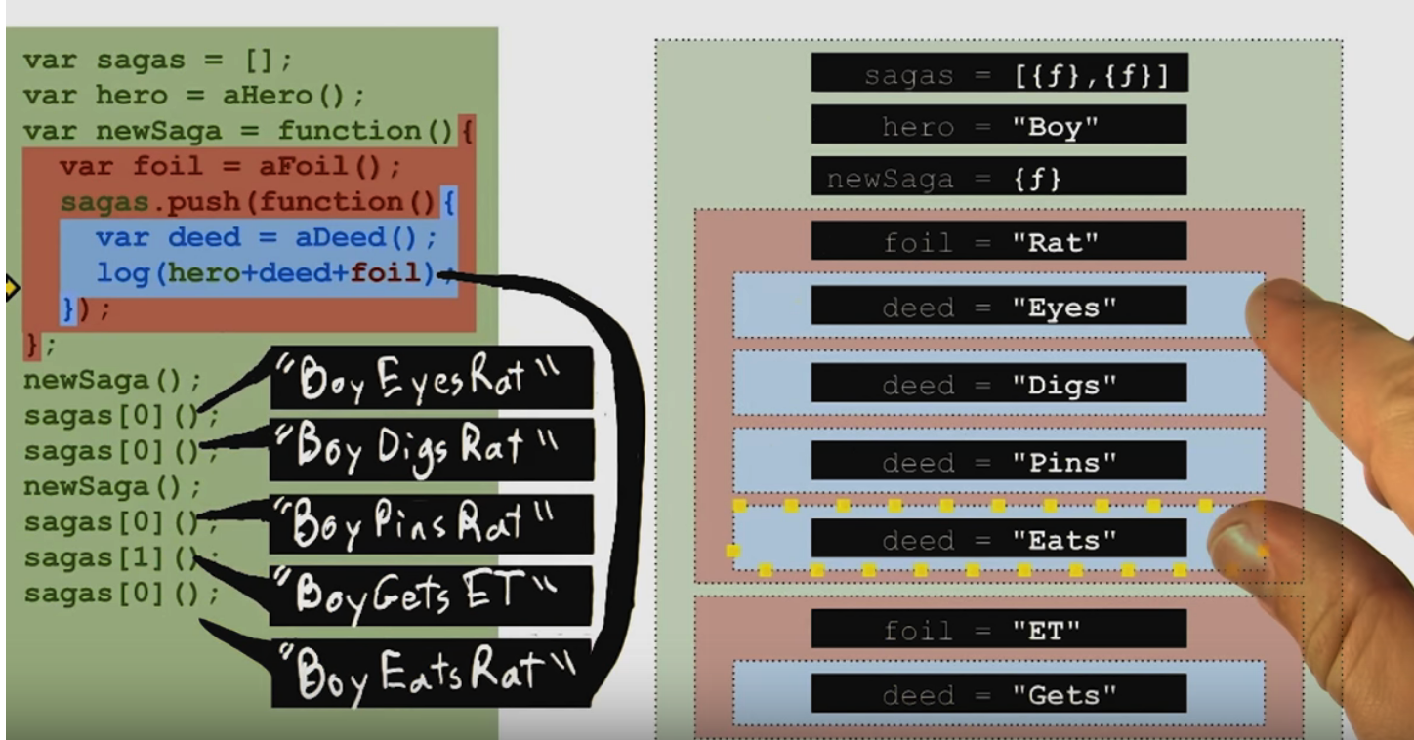

2.

reference from Udacity

key word : this

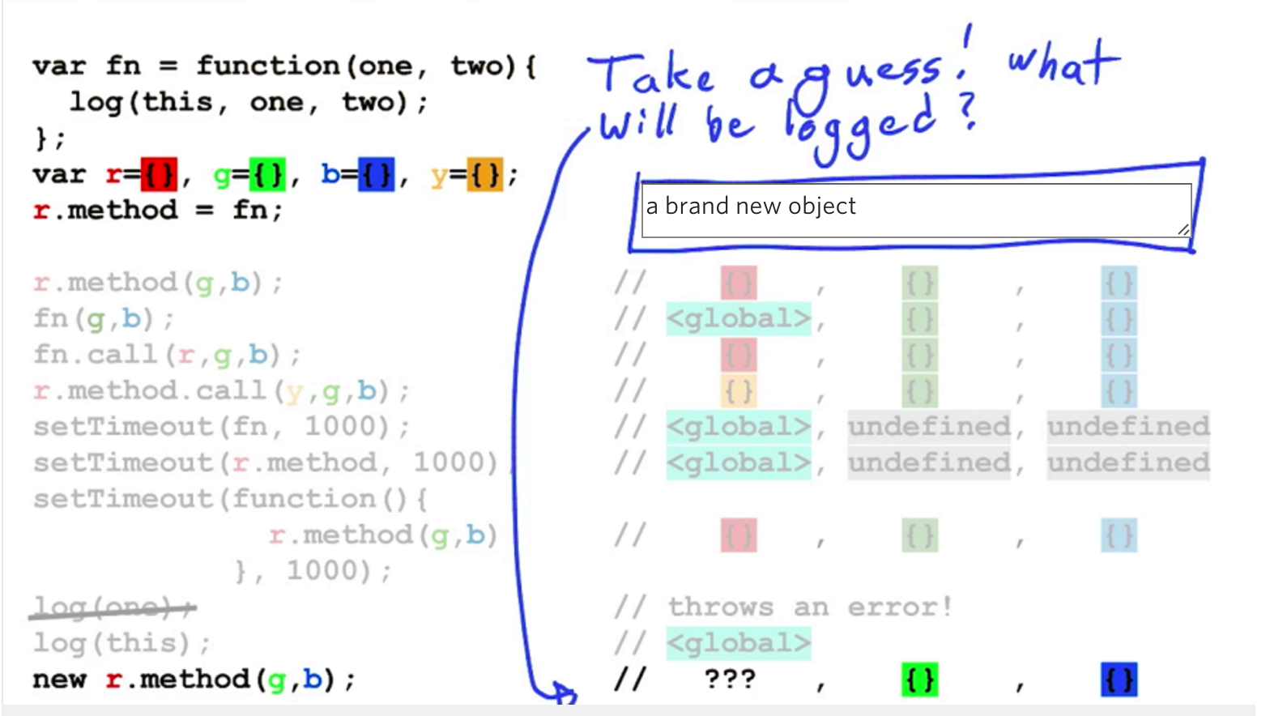

3.

Prototype chains: this is useful technique for code sharing and for saving memory.

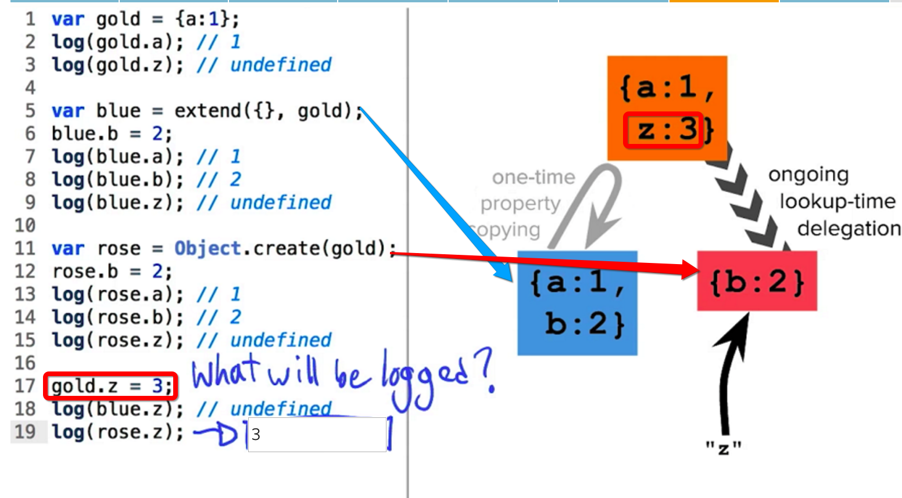

4. Object Decorator Pattern

code reuse

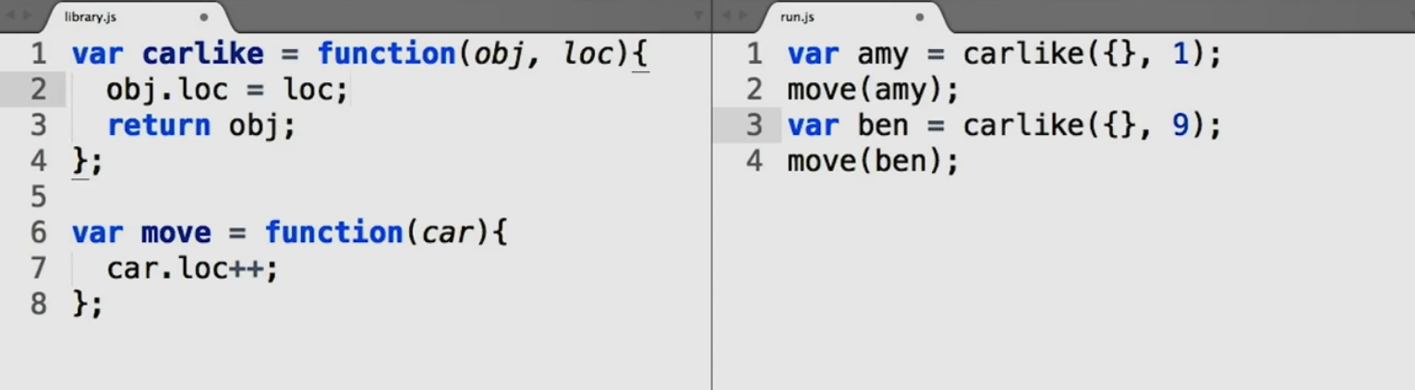

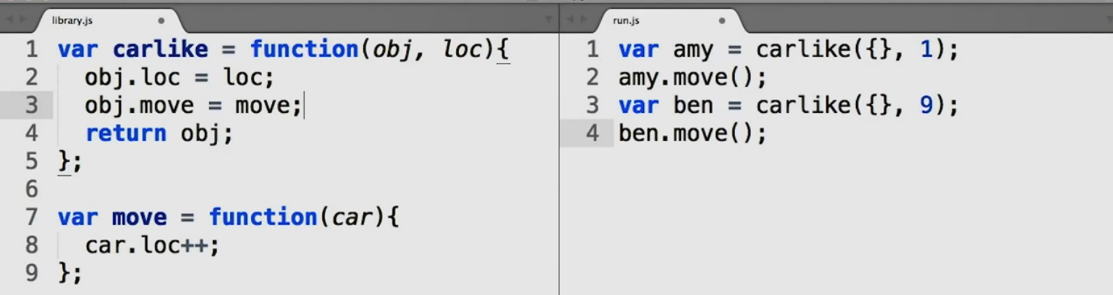

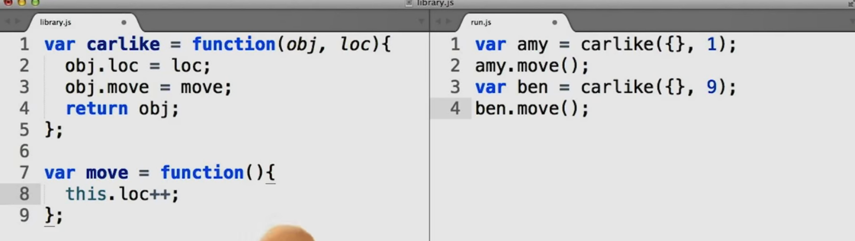

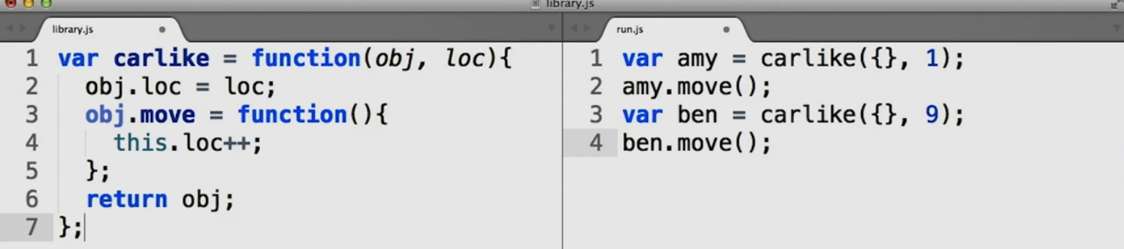

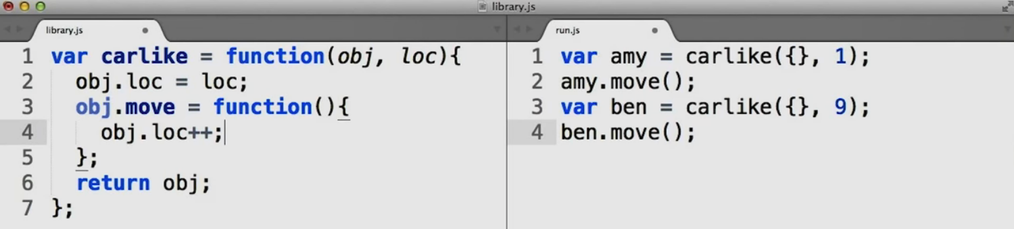

5.

function class pattern

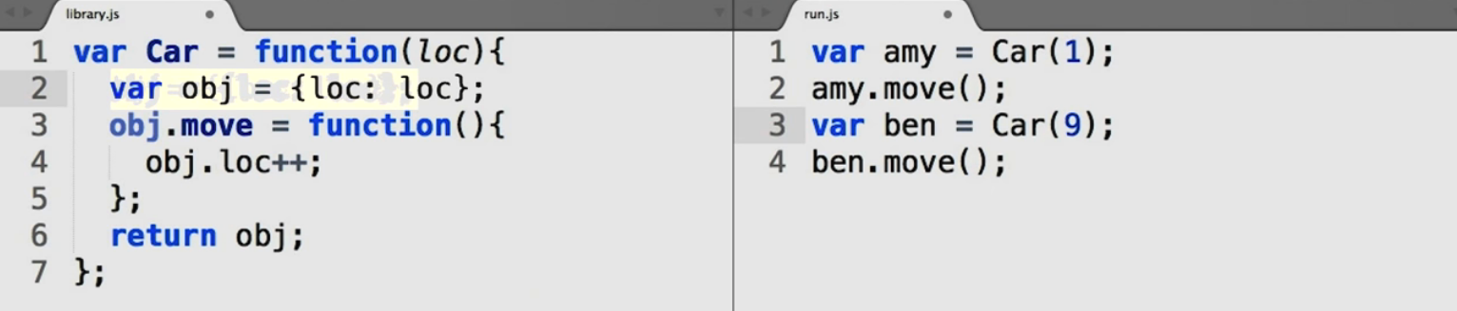

reduce duplicity:

this replaces obj because this function is being called as a method on objects created withCar.

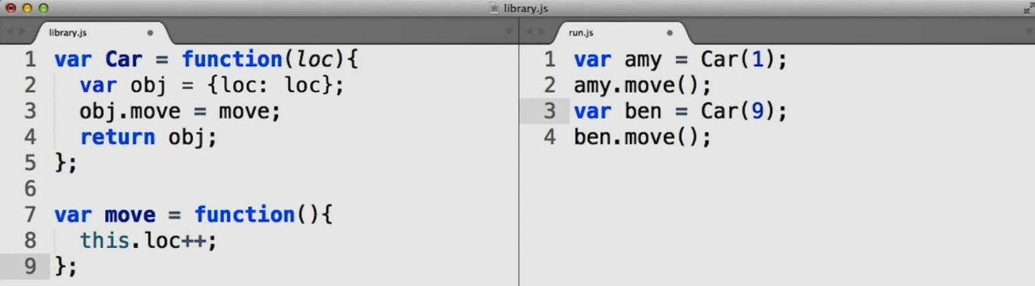

Functional shared patterns

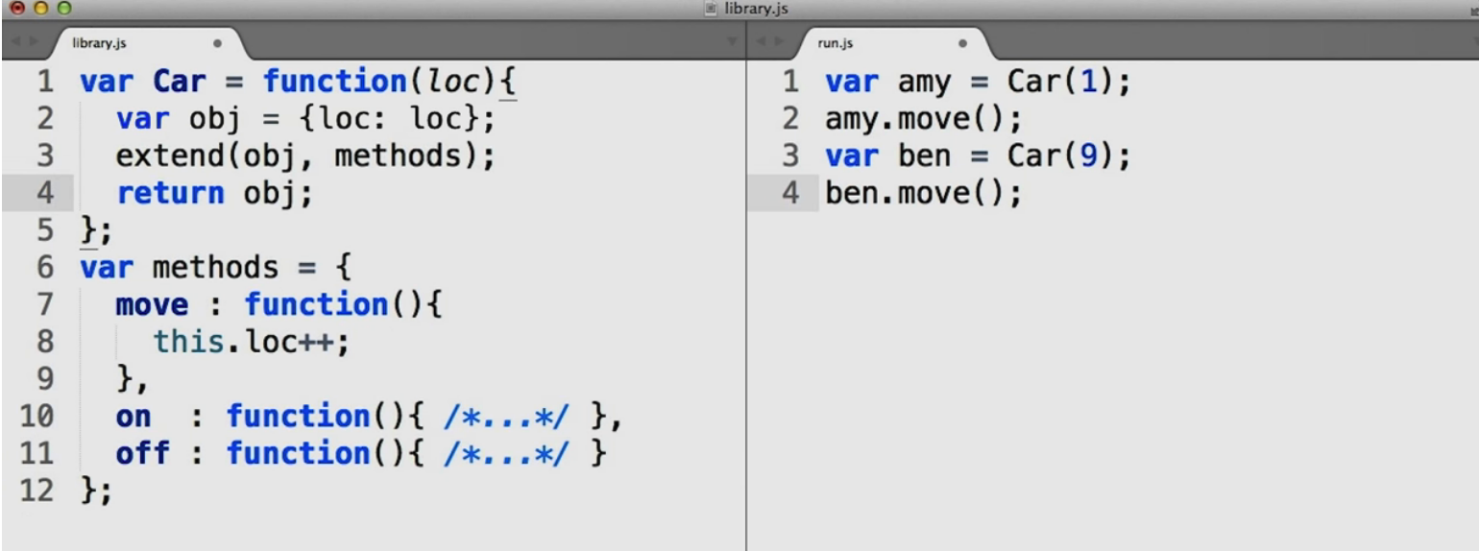

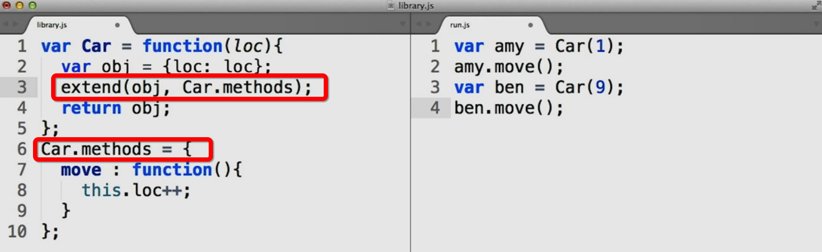

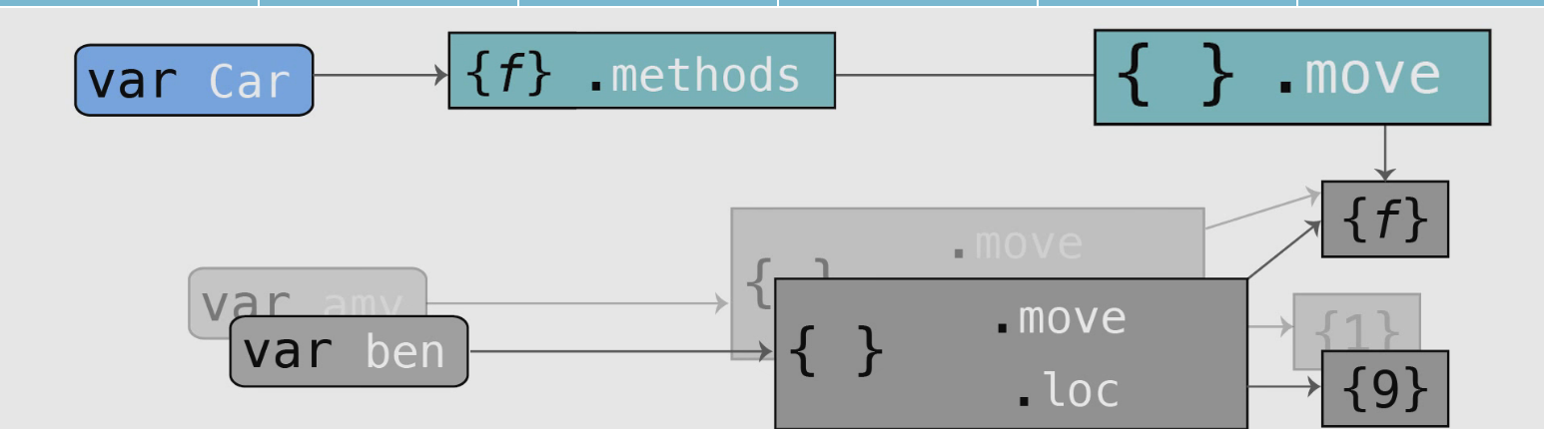

6.

prototype classes

prototypal pattern

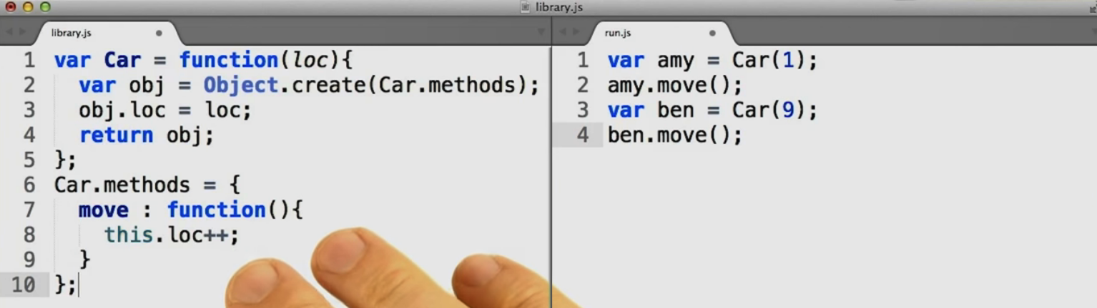

Constructor Prototypes

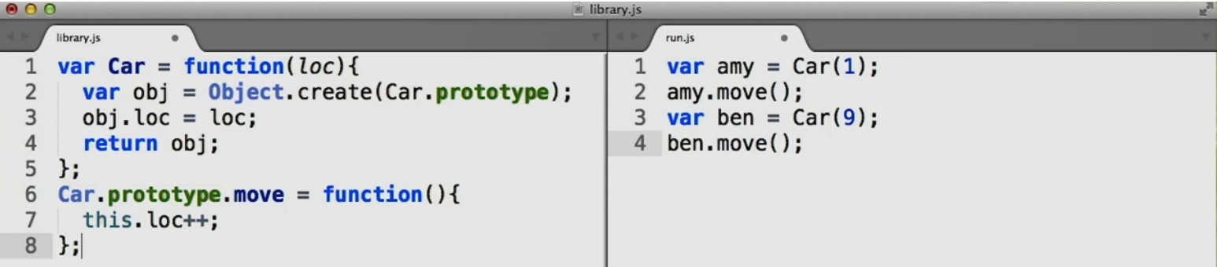

7.

pseudocalssical patterns

Constructor Mode:



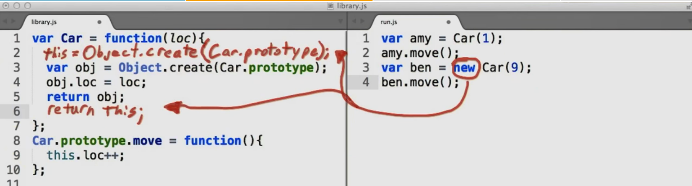

new provides us with the equivalent of lines 3 and 5 in our function, so we don't need them any more ... provided that we consistently use new!

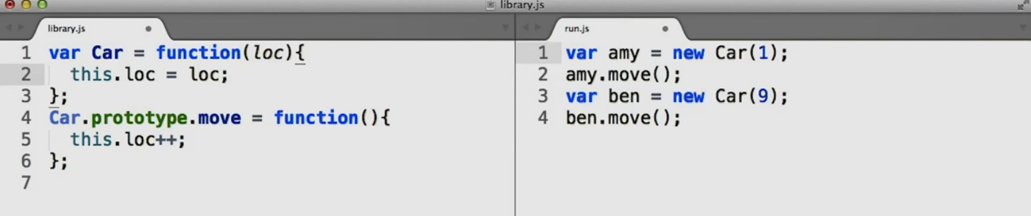

8. Superclass and Subclass

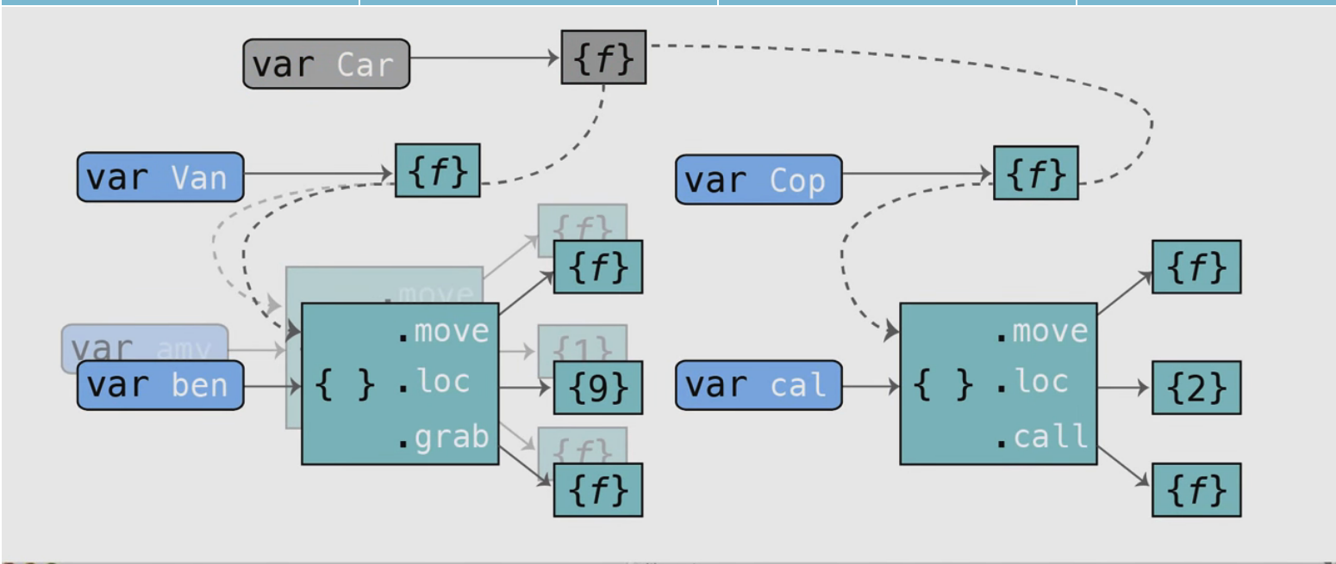

use functional pattern

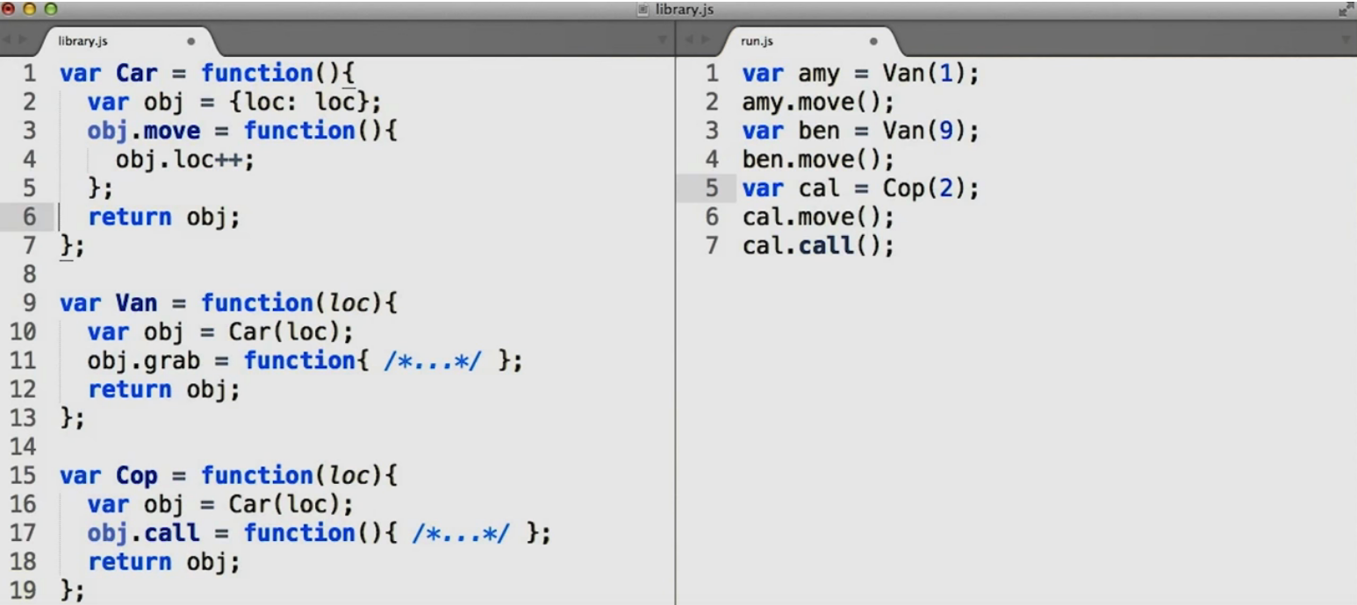

9. Pseudoclassical Subclasses

use Pseudoclassical pattern

 Subclass Property Prototype Delegation

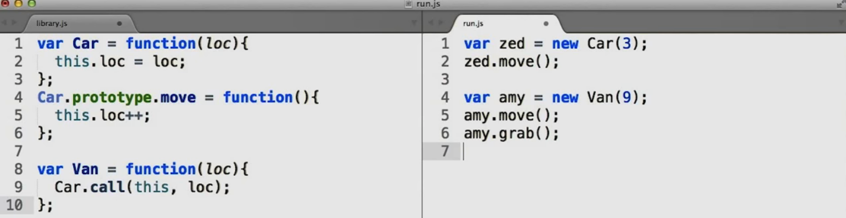

Subclass Prototype Delegation

